“汉语桥”平台上课注册指南

"Chinese Bridge" registration guide

“云端相遇，走进中国”项目中的所有课程需要在”汉语桥“上观看。

All courses in the "Meeting on Cloud, Entering China now" program need to be viewed on "Chinese-Bridge".

已经在上海政法学院申请系统完成注册（已获得申请编号）的同学请完成汉语桥网站注册。

If you have already registered in SHUPL’s system: http://lbzs.shupl.edu.cn, (you have already obtained a application number), please complete the registration on the Chinese-Bridge website.

第一步：打开网页，输入网址：http∶/bridge.chinese.cn/online/camp，点击图中红框②“注册”按钮进入账号注册页面。

Step1: Open the webpage and enter the URL: http∶/bridge.chinese.cn/online/camp. Click the red box② in the picture- "Join Now" button- to enter the account registration page.

、

第二步：点击红框③“注册新账号”。

Step2: Click the red box③:“Sign up for a new account”.

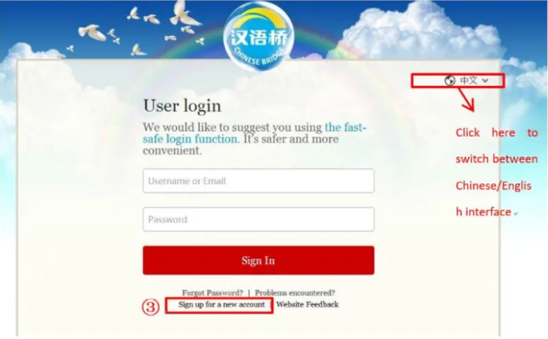

第三步：按照图中红框④内容依次填写，最后点击红框⑤“注册和登陆”，注册新账号。

Step3: Fill in the red box ④ in order, and finally click the red box ⑤ "Register and Login" to register a new account.

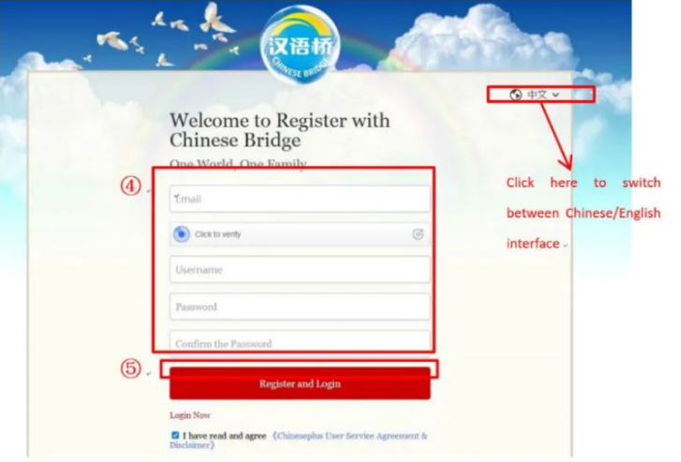

第四步：注册成功后等待网页自动登录账号，网页刷新显示如下界面。请按照指示完善个人信息。

Step4: After successful registration, wait for the webpage to automatically login to your account, and then the webpage will refresh to show you as the following screen. Please follow the instructions to complete your personal information.

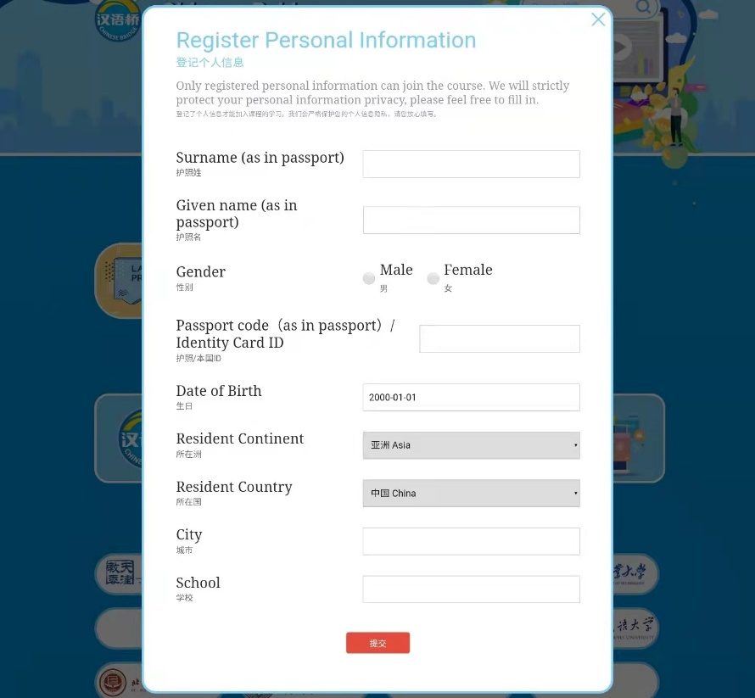

第五步：看到注册时的账号名在图中红框⑥处显示代表注册完成。

Step5: If you see your account name is displayed in the red box⑥，your registration is complete.



请注意：注册成功的学员将使用这个账号进入课堂上课，请妥善保存自己的账号。

ATTENTION：Students who have successfully registered will use this account to enter the online classroom, please keep your account properly.